Version Control System:SVN

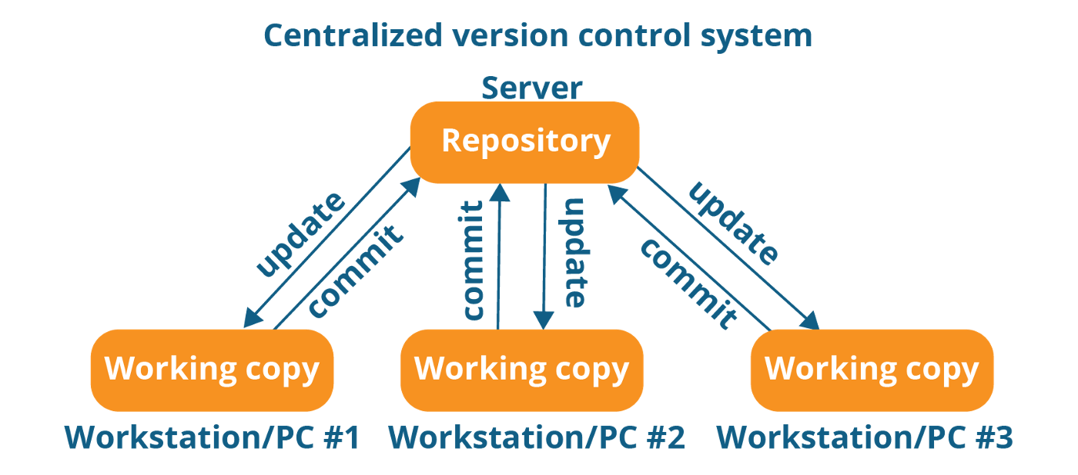
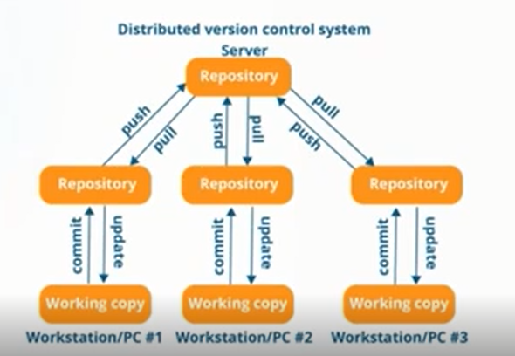
Git:--- GUI., bash(cmd)--local Repo (.git)
maven-- .m2
Github:- public ,private()

project: FB

Account Creation—p1- lRp1

Login-- P2
Post-- P3

- Step: Write code-- done
- Move the code in Local Repo (.git) using git

initailise git local repos:
git init

to Add the files in local Rep
git add <file_name>
git add .

git add test.txt

Git status-- git status

commit the code:
git commit -m “Created New”

- push our project on Github:

git config --global user.email “github email id”
git config –global username “”

git push -u origin master(branch name)

p1--- Day1(File, File2)-- github (master – stable code,Error Free)

P2--- Day2(File1 + File2 = master – stable code

+File3)

Github: master--F1+F2--m1()

Day2-- code conflict------------
p1 ----FB(P1 Branch--File4)
p2---FB(P2 Branch-- File3)---m1()
p3---FB(P3 Branch-- File5)

code Review Concept:
P1- Pull request by Dev. To Lead------------------>mistakes--error code
P2- Pull request by Dev. To Lead
P3- Pull request by Dev. To Lead

master branch: Feature Barcnh code merge in master barnch
code conflit

FB to master branch

What's Git?
Git is a distributed version control system (DVCS). "Distributed" means that all developers within a team have a complete version of the project. A version control system is simply software that lets you effectively manage application versions.

- Keep track of all files in a project
- Record any changes to project files
- Restore previous versions of files
- Compare and analyze code
- Merge code from different computers and different team members.

git - A repository is just a directory (a folder) in your project's root directory.

LocaL Repo:
repository on your own computer will be called local.

Remote Repo: A remote repository is like a public storehouse located in a different building. remote repositories such as GitHub, BitBucket, and GitLab.
A remote repository also serves as a central hub to which members of a web development team can connect to access project code.

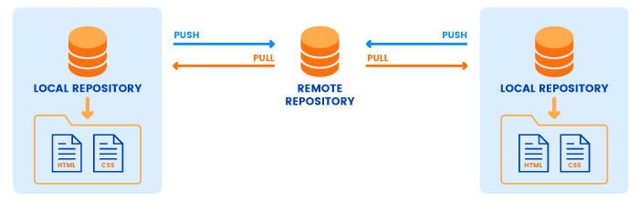

HOW TO CREATE PROJECT USING COMMAND IN GITHUB
- Commands to move the project on Github:-
- git init
- git add .
- git commit -m “message”
- git remote add origin <remote-repo-url>
- git push -u origin master

- Add the code in Remote Repository ion Master Branch
- To list all the branches name-→ git branch
- Create a new branch—git branch MyNewBranch
- To start working on the branch, first need to checkout means switch from Master branch to newbranch- git checkout MyNewBranch
- Do some changes like ---
- Create New file ---touch NEwFile.txt
- Add New file in NewBranch→ git add . or git add -all
- git commit –m “New file added”
or to add and commit the files in one go :-> git commit -a -m "Do something once more"
- git push –u origin MyNewBranch
- Now, Merge the code of NewBranch Code into Master branch
- First need to switch(checkout) to master branch-> git checkout master
After this command on local machine, it also switch to branches , means files dipslyed in newbanch will not be visisble, because we switched to master branch and this branch having no new files.
- Merge the code into master –> git merge MyNewBranch
- Push the code into master branch-> git push –u origin master
- To Delete the NewBranch from Local Repository not from Remote Repo. (make sure you have checkedout from that branch which you want to dlete)→ git branch –d MyNewBranch
- To delete the NewBranch FromRemote Branch-> git push origin –delete MyNewBranch
- To copy the whole code from remote Repository to My System->
git clone https://github.com/Mshaveta/BranchMerge.git
- If any person make changes in file and have to snd to remote repo then
- Add files in local repo.
- Commit the code
- Push the code to master branch using command: git push
- To get the changes (which are done by other developers) on local System we need to use the command:
git pull

- To remove files from the staging area, use the following command
git rm --cached my-file.ts
- To see the list of all files: ls
- TO check the log -→ git log

Difference Between clone and pull command:
- If you clone a remote repository, Git will:
- Download the entire project into a specified directory; and
- Create a remote repository called origin and point it to the URL you pass.
- The last item simply means that you don't need to run "git remote add origin git@github.com:YourUsername/your-app.git" after cloning a repository. The "clone" command will add a remote origin automatically, and you can simply run "git push" from the repository.

When you run the "pull" command, Git will:
- Pull changes in the current branch made by other developers; and
- Synchronize your local repository with the remote repository.
- The "pull" command doesn't create a new directory with the project name. Git will only pull updates to make sure that you’re the local repository is up to date.

To remove files from the staging area, use the following command
git restore --staged .

Deleting a branch LOCALLY
Git will not let you delete the branch you are currently on so you must make sure to checkout a branch that you are NOT deleting.

For example:
git checkout master

Delete a branch with
git branch -d <branch>.

To Delete Remote Repo:
git push origin --delete <branchName>

Delete Files From Git Repository only
In some cases, you want to delete files from the Git repository but not from the filesystem, you have to execute the “git rm” command with the “–cached” option.

$ git rm --cached <file>

$ git commit -m "Deleted file from repository only"

$ git push

